Murray State University

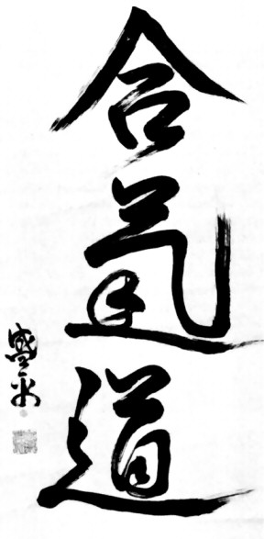
Aikido Club

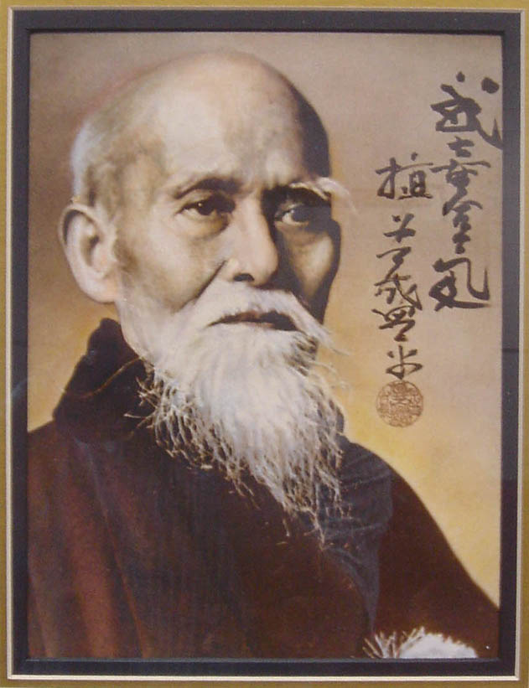
Murray State Aikido Club Constitution
Article I: Name & Purpose
 | The name of this Club shall be the Murray State University Aikido Club.
 | The main purpose of the Club shall be to provide an environment that encourages the social, spiritual and physical development of its members. Toward this end, the primary activity of the Club shall be the practice of traditional Aikido as formulated by its founder, Morihei Ueshiba.
 | An attendant purpose of the Club shall be to provide members with the means to continue their development and practice of Aikido when they leave Murray State University through:
(1) | fostering relationships with the other similarly affiliated Aikido clubs in the area, including providing opportunities to train under other instructors (and particularly, Locally Associated instructors) at the Club dojo;
(2) | providing the opportunity to train under other instructors at other dojos; and
(3) | providing senior members with the Aikido skills and supervised teaching experience (the latter at the discretion of the Chief Instructor) needed to begin other Aikido clubs.
Article II: Membership
 | Membership in the Club shall be open to all interested persons. In conformity with MSU rules, at least 51% of the membership shall be Murray State University students, and the Club shall make a special effort to recruit from the University community.
Article III: Affiliation
 | This Club shall be associated affiliated with the Aikido Schools of Ueshiba (ASU) and Locally Associated with the Nashville Aikikai for the purposes of advanced training and Aikido fellowship.
Article IV: Governance
 | Division of Responsibility: The Club is a cooperative effort in which all members are jointly responsible for the development of each individual. The Chief Instructor of the Club acts as leader and facilitator in this effort, and thus has primary responsibility for the training aspect of the Club as Director of Instruction. Primary responsibility for administrative matters shall fall on the Club Officers.
 | Governing Documents: The Club shall be governed in conformity with procedures set out in the Murray State University club rules.
 | This Constitution shall be the basis of Club participation, training, selection of instructors and selection of officers. In addition, the Club may adopt bylaws that are necessary or expedient to the governance of the Club, and/or which shall provide notice of procedure to members and instructors.
Article V: Club Administration
 | During the Spring semester of each academic year, the Club will elect a president, vice-president, secretary and treasurer. These positions are open to all registered students, and voting is by simple majority of all Club members. The duties of these officers are explained in detail in Chapter One of The MSU Aikido Club Bylaws.
Article VI: Club Instruction
 | Instructors: Choice of the Chief Instructor shall ultimately lie with the members of the Club. Considerations such as safety-consciousness, dedication to and continuing training with the ASU, teaching ability and ability to attract and retain new members are all important in this choice.
 | Other instructors may include Club members with the most experience (in years studied or in rank) in ASU Aikido, at the sole discretion of the Chief Instructor. The Chief Instructor may at any time designate Associate Instructors in order to draw upon their special skills, to give them teaching experience, or to act as substitutes when needed. Such Associate Instructors shall abide by any Instructor Guidelines provided in advance by the Chief Instructor. The Chief Instructor may also ask members who are also Safety Officers to act as substitutes without asking such members to become Associate Instructors.
 | In order to obtain the highest quality leadership and instruction, the Club shall make it a goal to compensate the Chief Instructor commensurate with the Club's budget. Such compensation may include (1) payment of the Chief Instructor's ASU and Club dues, (2) payment of certain fees associated with the Chief Instructor's advanced training at ASU seminars and attendance at the ASU Annual Meeting, (3) payment of fuel expenses associated with the Chief Instructor's travel to Locally Associated dojos. Associate Instructors may also receive the first type of compensation, dependent on available Club funds. The Chief Instructor and Club Officers shall negotiate this compensation every year, considering the Club's budget and fundraising.
 | In the event a new Chief Instructor is needed (e.g., Chief Instructor is leaving, vote of two-thirds of the members), the present Chief Instructor shall choose a replacement based on the above criteria and in consultation with all available members and Chief Instructors of Locally Associated dojos, especially the acting Club Officers. The Chief Instructor, upon approval of the Club Officers, will then present a nomination for the new Chief Instructor at the next general meeting of the Club and over e-mail. Notice of one week must be given. whereupon The members will then vote to accept or reject the new instructor. Voting is by two-thirds majority, and all members may vote. Absentee voting is permitted.
 | It is anticipated that the Chief Instructor's consultation with Club members and Officers, and Locally Associated dojo leaders, will lead to the selection of a nominee favored by a majority of Club members. If, however, the nominee is rejected, the Chief Instructor shall begin the selection process again, and continue said process until an acceptable replacement is found.
Article VII: Removal of Members
 | The practice of Aikido is designed to encourage mutual respect and an active concern for the welfare of others, including one's own practice partners. Occasionally, however, an individual cannot or refuses to understand and follow this principle. In this case, the Instructor present shall attempt to impress upon the offending member the need for respect, care and safety in the practice of Aikido and interaction with fellow Club members. If one or more of these attempts are unsuccessful, the Instructor shall notify the Chief Instructor and all Club Officers about the member in question. Instructor(s) and Club Officers will meet with the offending member and will explain that any further violations will result in expulsion from the Club. If the offending member continues to disregard the safety and/or well-being of others, any combination of Instructor, Faculty Advisor, and Club Officers present will then inform the offender that s/he is expelled from the Club. After a period of one year, the expelled member will again be eligible for Club membership.
Article VIII: Amendments and Bylaw Adoption
 | Amendments to this Constitution can be made by a two-thirds vote of a quorum of active members. Quorum requires that at least ten members cast a vote. Absentee voting is permitted. Notice of one month must be given. Proposed amendments may originate from Club Officers or through the appointment by the Officers of a Committee entrusted with the revision of the Constitution.
 | Bylaws may be adopted each year by the membership of the Club. Such bylaws will remain in effect until they are repealed by a vote of the general membership of the Club. A simple majority is necessary to adopt or effect a repeal of any bylaws.
MURRAY STATE UNIVERSITY AIKIDO CLUB BYLAWS
CHAPTER 1:
OFFICER RESPONSIBILITIES
1. PRESIDENT:
The President is the executive administrative head of the Club. As such, the President's responsibilities include:
1) | chairing Executive Committee meetings;
2) | appointing special committees;
3) | acting as liaison with Chief Instructor and Club Instructors as a group;
4) | acting as liaison between the Club and other dojos, particularly with the Nashville Aikikai and area associated dojos;
5) | representing the Club in all dealings with University officials, and
6) | regularly check the Club e-mail account.
2. VICE-PRESIDENT:
In circumstances when the President is unable to fulfill the responsibilities enumerated above, the Vice-President
shall represent the Club on a temporary basis and, if necessary, replace the President if s/he remains unable to
fulfill duties for an extended period of time. In addition, the Vice-President shall:
1) | oversee any committees established by the President;
2) | assist other Officers in their duties, as needed;
3) | manage the Club web page in the event Club Webmaster is unable;
4) | maintain communications with other Aikido dojos regarding upcoming events; and
5) | have access to the Club e-mail account.

3. SECRETARY:
The Secretary shall:
1) | be responsible for the minutes of each Executive Committee meeting;
2) | maintain Club roster information, including spreadsheets or membership book with membership information, including members' ASU numbers, rank, test dates and due payment dates, and inform the Treasurer when people have not paid dues;
3) | periodically file Tort Waiver information with MSU administration and ensure that adequate Tort Waiver forms are available in the dojo;
4) | keep the Club e-mail distribution list updated;
5) | regularly check the Club e-mail account; and
6) | regularly check Club mail and deliver items to the Officers and/or Chief Instructor.

4. TREASURER:
The Treasurer shall:
1) | be responsible for the collection of dues from members each semester and inform the Secretary when members have paid dues;
2) | maintain Student Organization Account (SOA), Murray State University Foundation (if existing) account funds;
3) | create a Budget proposal for the Club during the Spring semester in consultation with the Club President Officers; and
4) | have access to the Club e-mail accout.

5. CHIEF INSTRUCTOR:
1) | The Chief Instructor is not an Officer, but s/he shall also have access to the Club e-mail account.
2) | The Chief Instructor may also designate certain members to be paired with new members until the new members feel comfortable with Club procedures.
CHAPTER 2:
CLUB EXPENDITURES
I. | PURPOSE:
 | The purpose of this Chapter is to provide procedures for reimbursement of mandatory and approved discretionary expenditures made by members, officers and instructors of the Murray State University Aikido Club (Club).
II. | DEFINITIONS:
A | Mandatory expenditures include:
1. | Payment of fees incurred by Club members, Officers and Instructors necessary to maintain a reasonable number of Safety Officers for the Club;
2. | Payment of fees associated with authorized bank transactions for the Club; and
3. | Payment of other requisite fees or sanctions incurred by the Club.
B. | Discretionary expenditures include:
1. | Food and drink: Payment for food and nonalcoholic beverages for Club members, Officers and/or Instructors at a Club social event or meeting;
2. | Advertising: Payment for Club advertising materials such as chalk, paper and other supplies, as well as printing services and feeds to advertise in printed or other media;
3. | Fundraising: Expenses of creating merchandise or other materials for fundraising purposes;
4. | Instructor Services: Payment for instruction, including Club instruction time and fuel/food/lodging expenses;
5. | Seminar Expenses: Payment of transportation costs, mat fees and other specified expenses at regional seminars sponsored by a member dojo of the Aikido Schools of Ueshiba (ASU);
6. | Equipment: Expenses for replacement of or provision of new dojo equipment that is not reimbursed by Murray State University;
7. | Maintenance: Expenses associated with the upkeep or improvement of the Club dojo that are not reimbursed by Murray State University; and
8. | Donations: Charitable gifts made by the Club to the ASU, Aiki Atlas Foundation, or an ASU member dojo.
III. | APPROVAL PROCEDURES:
 | Club members, Officers and Instructors must seek approval as provided below to ensure reimbursement by the Club. Failure to follow these procedures may result in refusal by the Club to reimburse expenditures.
A. | Mandatory expenditures: No approval is necessary for reimbursement of these expenses; however, determination and selection of Safety Officers will be made each year by the Club instructors Chief Instructor.
B. | Discretionary expenditures: Approval by Club Officers as provided below is required before any expenditure is made.
1. | Informal approval: Food and advertising expenditures not to exceed twenty-five dollars ($25.00) may be approved informally by the Club President or a majority of the Club Officers.
2. | Formal approval: Food and advertising Any discretionary expenditures exceeding twenty-five dollars ($25.00), as well as other discretionary expenditures not otherwise specified in this section, shall be approved through discussion and vote of all the Club Officers, subject to the following procedures:
3. | The applicant proposing the expenditures shall have the opportunity to set forth in writing or orally, at the discretion of the Club Officers, the proposal for consideration by the Club Officers.
4. | A two-thirds (2/3) majority vote of the officers is required to approve the proposal.
5. | In the case of a tie vote by the officers, the matter will be submitted to a vote by all Club members at the next Club meeting. Notification of the vote shall occur not less than two (2) weeks prior to the vote. A three-fourths (3/4) majority of members present, including Officers, shall pass the proposed expenditure.
6. | Member approval: Decisions involving discretionary expenditures for:
- | the benefit of individual club members or
- | development of merchandise for club members
- | should be confirmed by a vote of the Club members at any Club meeting after or in addition to approval by vote of the Club officers. Expenditures such as: selection of Club design for T-shirts, etc., spending for member attendance at regional ASU seminars, and Club funding of seminars are instances where confirmation by vote of general Club membership should be sought.
7. | Financial constraints: No discretionary expenditure shall be approved or reimbursed by the Club which would result in a Student Organization Account (SOA) balance of less than fifty dollars ($50.00) at any time.

IV. METHOD OF PAYMENT:
In some instances, the Club can save money on expenditures through having our account billed directly.
Where time permits, those members making approved expenditures in the area should contact
the Club Treasurer before making purchases.
V. REIMBURSEMENT PROCEDURES:
Following a mandatory or an approved discretionary expenditure, the member, Officer or Instructor should
remit an official receipt of the transaction to the Club Treasurer not later than one (1) month after the expenditure.
Reimbursement will be made from Club funds in a timely manner, subject to the limitations described below:

1. | No reimbursements will be made without an official itemized receipt of the transaction; copies of the receipt are acceptable.
2. | Expenditures made during the summer months must comply with approval procedures set out above; a receipt of the transaction will be received and reimbursed by the Club Treasurer as soon as practicable, but this may be after the commencement of the fall semester.
3. | In cases of extreme necessity, reimbursement of an expenditure may be sought without prior approval of the Club. In such an instance, Club Officers should consider the following criteria when deciding whether to reimburse the expenditure:
a) | whether approval of the expenditure could have been sought, and if so, why it was not;
b) | whether the expenditure was necessary in light of the circumstances surrounding it;
c) | whether the Club will benefit from the expenditure in light of the cost;
d) | whether reimbursement of such types of expenditures are generally made by the Club; and
e) | whether other relevant factors should permit reimbursement in this case.

CHAPTER 3:
CLUB POLICIES
Pursuant to the goals of the Club, the following policies and procedures have been adopted. These policies
may be amended temporarily by a two-thirds (2/3) vote of the Club Officers, but this chapter of the Bylaws
should then be formally amended at the close of every academic year to reflect current Club policies.
Members shall be given a copy of these Club Policies every year.

I. | Club Dues
1. | Club Dues: Club dues shall be $30/semester (Fall and Spring), and $15/Summer (or $10/month in the Summer). Individuals may train for up to six classes in any given time period (Fall, Spring, Summer) before being required to pay dues. Members joining in the last two full months of a Fall or Spring semester may pay $15 dues.
2. | Financial Aid: Club Officers shall consider all applications for full and partial financial aid based on financial need, and they may grant such financial dependent on available Club funds. Financial aid recipients may be requested to do a service project for the Club, and they shall enjoy full Club benefits.  Financial Aid Form
II. | Benefits of Club Membership
1. | ASU Dues: ASU dues shall be paid in the Spring for all Club members in good standing, immediately for continuing or transfer members, and after the first kyu test for members who are new to ASU Aikido.
2. | ASU Seminars: All Club members are eligible to receive reimbursement of 50% of mat fees for out-of-town ASU seminars, provided receipts are presented to the Treasurer and Club funds are available.
3. | Training at Locally Associated Dojos: All Club members may (and are encouraged to) attend regular Nashville Aikikai and area Aikido classes free of charge while they are members in good standing at the MSU Club.
4. | Socials and Other Activities: All Club members may benefit from various club socials fully or partially funded by the Club dependent on available funds, participate in community service, etc.
5. | Training Manual: All Club members shall receive an ASU Training Manual.
III. | Responsibilities of Club Membership
1. | It is expected that all Club members will do their best to follow the direction of Club Instructors, as well as the Rules of the Dojo and Rules of Training posted in the dojo. Club members should also check in on the training attendance sheet and make sure the Secretary has their current e-mail address for Club mailings (if desired).
2. | The dojo is a cooperative effort. Club members are encouraged to take an active role, as time allows and to the best of their abilities, in all aspects of dojo functioning, including serving as Officers; serving on community service, fundraising, public relations, social, seminar, etc. committees; mentoring newer members; cleaning the dojo; etc.
IV. | Affiliations and Support
1. | The ASU:
Whereas this Club is affiliated with the Aikido Schools of Ueshiba (ASU), under the direction of Mitsugi Saotome Shihan and Hiroshi Ikeda Shihan, and
Whereas they have devoted their lives to the development of Aikido, and
Whereas this Club is a beneficiary of this dedication:
 | This Club undertakes to support and thank them by:
a) | maintaining close relations with other ASU dojos, particularly with locally associated dojos and other Midwest dojos;
b) | encouraging Club members and Instructors, especially the Chief Instructor, to attend as many ASU seminars and camps as possible, particularly those taught by Saotome Shihan and Ikeda Shihan;
c) | sending the ASU $5 extra for every mudansha member and kyu test, and sending $10 extra for every yudansha member;
d) | raising funds in various special projects to donate to Saotome Shihan's Aiki Atlas Foundation and/or the ASU;
e) | inviting locally associated and other ASU instructors to teach at the Club;
f) | sending Club representatives to all important ASU functions, such as ASU Annual Meetings;
g) | submitting information (e.g., tests, membership) to the ASU in a timely and professional manner;
h) | maintaining a library in the dojo of Saotome Shihan's and Ikeda Shihan's books/videos for Club member check-out; and
i) | informing members about Saotome Shihan's and Ikeda Shihan's books, videos, and other offerings (e.g., calligraphy, Bu Jin Design items).
2. | Locally Associated Dojos:
 | This Club also maintains strong local associations with the Nashville Aikikai and other area Aikido organizations.
a) | encouraging Club members to train in these dojos (free of charge) and urging Club Officers to maintain contact with these dojos;
b) | regularly inviting instructors of these dojos to teach seminars at the Club, and offering favorable compensation;
c) | providing current members of these dojos the benefit of free training at the Club;
d) | consulting with these dojos in the planning of seminars; and
e) | collaborating with these dojos for the purposes of advanced training for advanced students and instructors, and for the purpose of test quality control and dan test preparation.


